

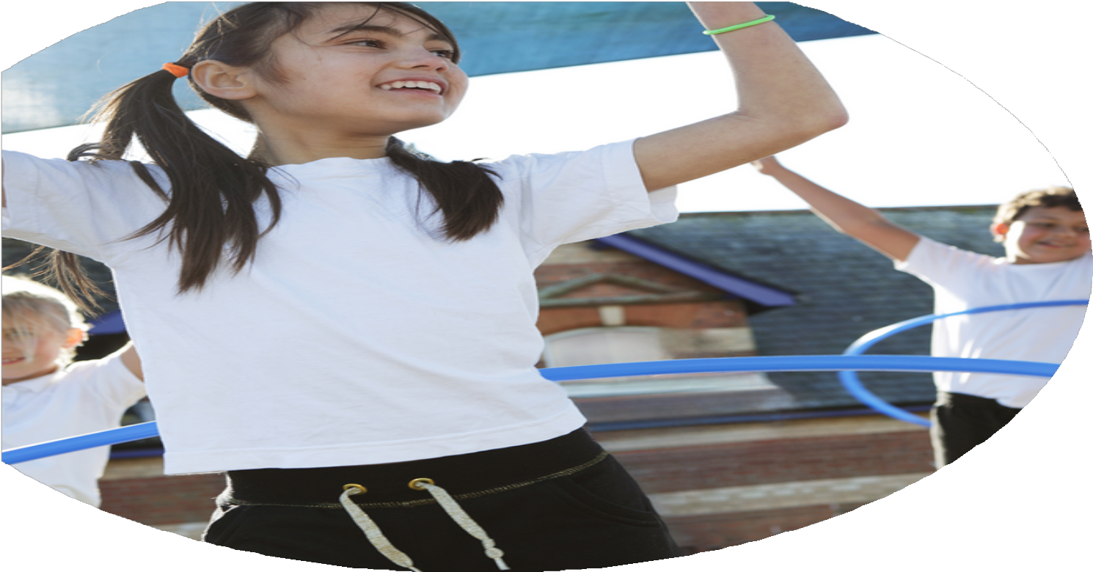
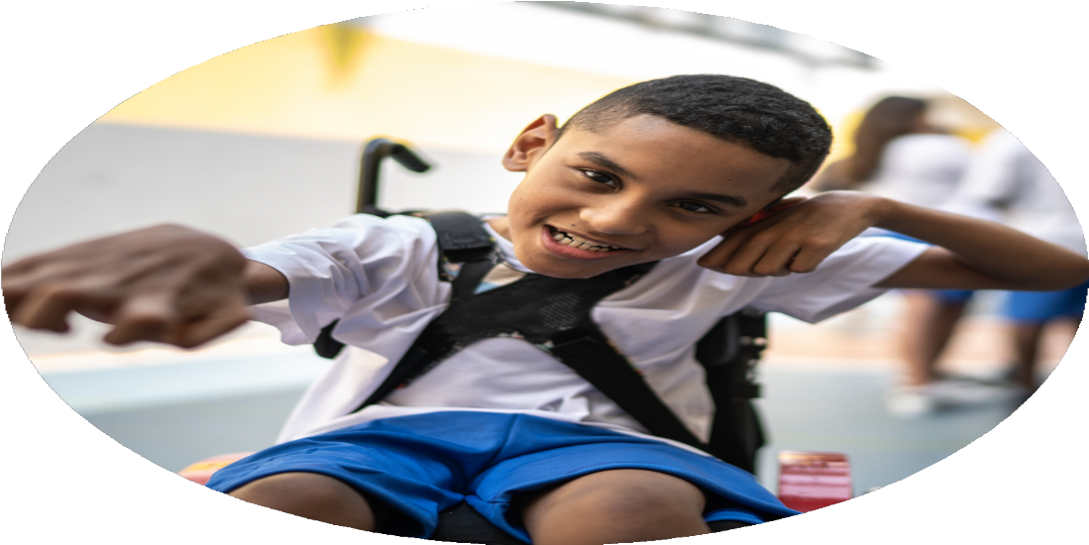




PE Funding: 2024/2025

Evaluation Form

Commissioned by
Images courtesy of Youth Sport Trust

PE Funding Evaluation Form

It is intended that this template should be used as preparation for the completion of the statutory digital reporting tool being introduced this academic year. You can upload data (including swimming) from this template onto this platform once it becomes accessible.
Before you decide how you are going to use the funding for this academic year you should reflect and evaluate the impact of your use of the funding in 2023/24.
All spending of the funding must conform with the terms outlined in the Conditions of Grant document. The template is a working document that you can amend/update during the year.
Based on your evaluation of last year’s funding you should decide what you intend to do this academic year, how you will do it, and what impact you expect it to have.

It is important that the funding is used effectively and based on your school’s needs.
You must use the funding to make additional and sustainable improvements to the PE and sport in your school. You must develop and add to the PESSPA activities that your school already offers.

Summative digital reporting from June 2025 will continue to include swimming and water safety information therefore funding can be used to provide top-up lessons where necessary to ensure pupils meet national curriculum swimming requirements.

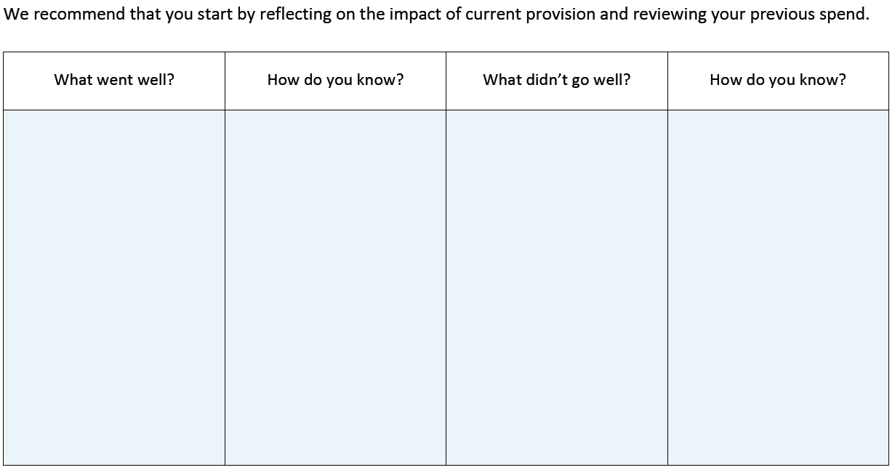
Less children participating after school ( low numbers) evidenced through tracking.
Staff capacity after restructure is becoming more limited as staff are supporting sports competitions rather than clubs.
As a result, there is no spare capacity to run after school clubs.
In addition to this, there is an increasing number of children who are unable to participate in clubs after 4pm due to mosque commitments so participation in after school clubs has dropped off.
The daily mile became inconsistent across the year due to staff and governor commitments.

In 2024/25 we will try to mitigate this with new wrap around provision.
Our plans for the year were to engage more children in taking up 60 active minutes within the school day and increase participation levels.

Overall, we were successful with this goal.
This year, we provided extra curricular clubs in: Girls football, boys football, yoga, sporthall athletics, athletics, glow dodgeball, tennis, rugby, trigolf, ultimate frisbee, Kurling, netball, Fundamental movements skills, daily mile, martial arts, archery and hockey

- 100% of our Y5 and Y6 children were given the opportunity to represent school this year on at least 4 occasions;
- 100% of KS2 children represented school at events this year
- 100% of our KS1 pupils represented school during this academic year.
- 2 teams into the HRVSSP netball league, with one team finishing 4th in HRVSSP league and 4th in the tournament.
- We were able to participate in the girls football league
- Participation in the Dance Festival at Burnley mechanics, sending boys and girls from Y1 to Y6.
- We sent 2 teams to participate in the Lancashire Youth Games: Y3/4 Striking and Fielding and Y3/4 Sports Day and finished in SILVER medal position at the latter
- We won GOLD in the HRVSSP orienteering competition.
- we won GOLD and BRONZE medals in the HRVSSP KS1 New Age Curling competition
- In swimming, we returned with 1 silver and 2 bronze medals and our girls' team finished 3rd overall

Registers for lunchtime clubs, tracking of children’s participation in clubs and competitions.

What are your plans for 2024/25?

Intent
How are you going to action and achieve these plans?

Implementation
- Provide a balance of competitive and non-competitive activities through intra and inter-school events, and the transport to these events where necessary.
- Provide general physical activity clubs which develop health and fitness, for example Change for Life clubs, daily mile.
- Provide clubs that help develop fundamental movement skills for those children who are not achieving ARE.
- Ensure that every pupil is offered the opportunity to attend a minimum of two extra curricular activities each week
- Ensure that the school regularly participates in HRVSSP ( Hyndburn and Ribble Valley School Sports Partnership) events that promote competitive opportunities and physical activity.
- Ensure that every pupil in KS1 and KS2 is given the opportunity to represent school at least once each academic year.
- Employ a range of qualified and experienced auxiliary coaching staff for lunchtime and after school provision and implement quality assurance through the subject leader and head teacher.
- Provide CPD for staff
- Subscribe and make use of Lancashire “PE Passport” for planning, tracking, monitoring, and CPD opportunities ( Video clips available)
- Develop and subscribe to health education partnerships, and learning platforms and enrichment days/visits

All of our planned activities are designed to build children’s confidence, self-belief and self-esteem. They should help the children to see the benefits of activity and exercise: learning that it is fun and has benefits for our mental and physical wellbeing. In the long term, we hope that it will encourage children to continue this healthy and active lifestyle once they leave us and that it stays with them for life.

We intend to build on our previous successes of providing 60 active minutes within the school day. Through providing a variety of opportunities, including traditional and non traditional sports, we hope to help all children find a physical activity that they enjoy and will potentially continue outside of school or beyond their years at Balderstone. We hope to increase fitness and participation levels.

We hope to provide opportunities so that all children are able to ride a bike by the time they are in KS2 and enjoy this activity.

What impact/intended impact/sustainability are you
expecting?
How will you know? What evidence do you have or
expect to have?
- Children will choose to participate in clubs and be active at lunchtimes
- Monitoring/tracking of children – Lancs PE app; CTs individual tracking records.
- Observing which children are more reluctant to sign up to clubs
- CPOMS records
- Positive behaviours and attitude when representing school at events
- Children actively seeking activities outside of school due to the impact of in school participation.

- Children understand and value the importance of physical activity.
- Children progress in different domains of learning
- Children are confident and have good self esteem , both generally and when participating in activities
- Children know how to improve. They set targets for themselves and compete against others individually and as team members.
- Children have the knowledge to achieve their potential
- All children’s achievements are valued.
- Each child becomes a good sports person, who plays fairly and can develop a team spirit.
- Good playtime relationships with less social ‘incidents’ over lunchtimes
- Children recognise the importance of healthy mind, body and soul
- Children are able to look after themselves

What impact/sustainability have you seen?
What evidence do you have?
Registers show all children have participated in numerous lunchtime clubs. our data tracking shows strong in-school engagement.
Targeted intervention each week provided for less active children and children working towards the standard required and assessments show progress of these children.
Silver medal position in orienteering; Bronze medal in curling; Bronze medal position in netball league.
EYFS children able to use their balance bikes confidently, evidenced on our social media platforms.
Feedback from pupils and parents show a love of physical activity and enjoyment of PE and school sport
Children with anxiety and/or learning needs recognise the impact of physical activity on their mental health
Less incidents at lunch time from providing children with structured activities evidenced in CPOMS
Children understand fair play and our sporting values and participate in line with these.

We have made significant progress in engaging more children in physical activity and increasing participation in the School Games. Through keeping registers we have been able to track participation and target children where appropriate.
We have successfully offered a wide range of extra-curricular clubs. including sports such as football, athletics, dodgeball, martial arts, cricket, ensuring broad and inclusive opportunities for all pupils. We have provided structured lunchtime clubs which aim to increase participation, including a FMS club to further develop the skills of those children who are less physically able; a C4L club targeting the less physically active with an aim to inspire of love of physical activity along with a variety of traditional and non traditional sports for all children to engage in. We have also implemented a girls’ football club, which has seen great attendance over the year.
We strive to ensure that 100% of our KS1 and KS2 pupils represent the school at events, which we have achieved ,with Y5 and Y6 students given the chance to represent the school on at least four occasions. Our involvement in the School Games and associated events has had a clear impact—children from all year groups took part in competitions, including the Dance Festival, HRVSSP leagues, festivals, competition and the Lancashire Youth Games. We also celebrated success in New Age Curling, netball and Orienteering. These achievements demonstrate enhanced engagement and a culture of participation across the school,
This year, we have worked towards addressing these challenges of engagement outside of school hours through new wrap-around provision to sustain and grow participation further.
Our recent pupil and parent voice demonstrated an overwhelmingly positive response towards our provision.

